# Deploying Azure File Sync

For deploying file sync service, we need to configure a few prerequisites. They are as follows.

1. Azure Storage Account.
2. Azure File Share.
3. Azure File Sync.
4. Windows Server Machine.

Let us follow each of these steps to deploy a file sync solution.

**(Note – Azure File Sync is not only in specific regions like Australia East, Canada Central, Canada East, Central US, East Asia, East US, East US2, North Europe, Southeast Asia, UK South, West Europe, West US. So choose the location of your file sync accordingly.)**

**Creating Azure Storage Account:**

Go to **+ Create New resource** and choose **Storage->Storage Account.** Give an unique name, and choose the same location that is given in the image below. Choose a resource group and click on create.

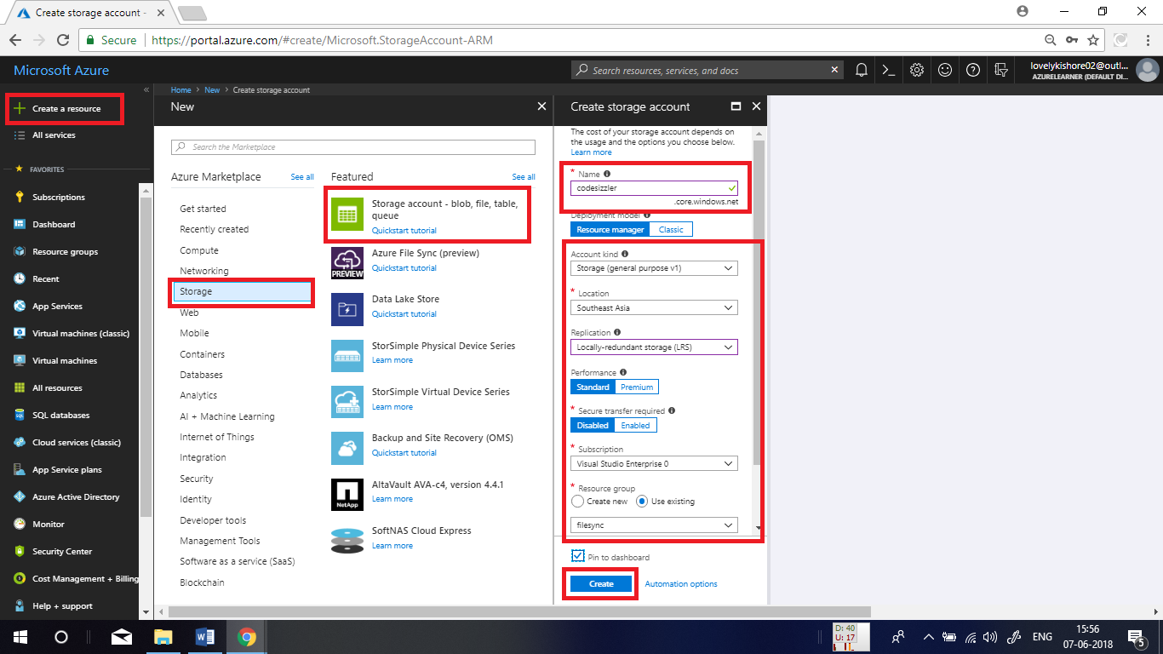

**Adding File Share:**

Once the storage file is deployed, click on the **Files** option in the overview page.

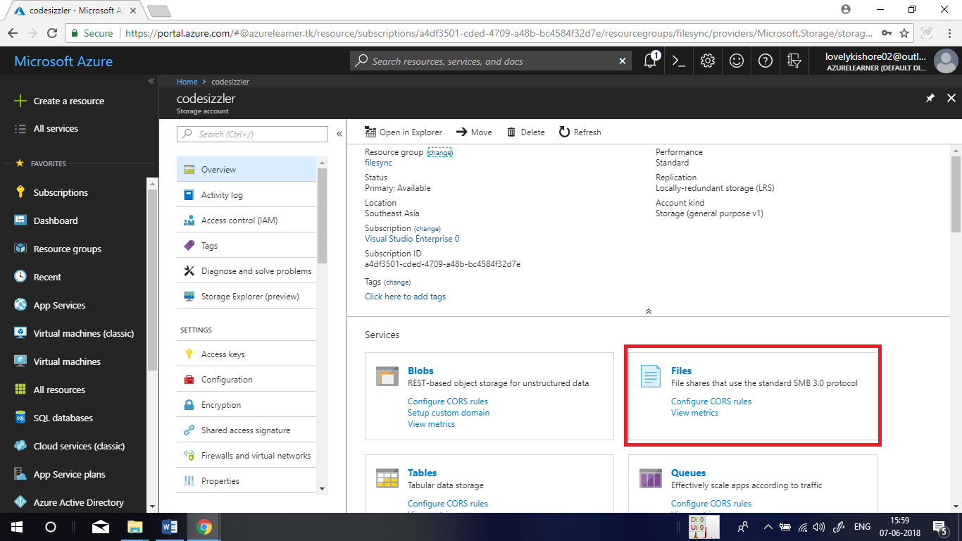

Now, click on **+ File Share** option to add a file share. Give a name, some size that matches to the size of files that you will be syncing and click on OK. 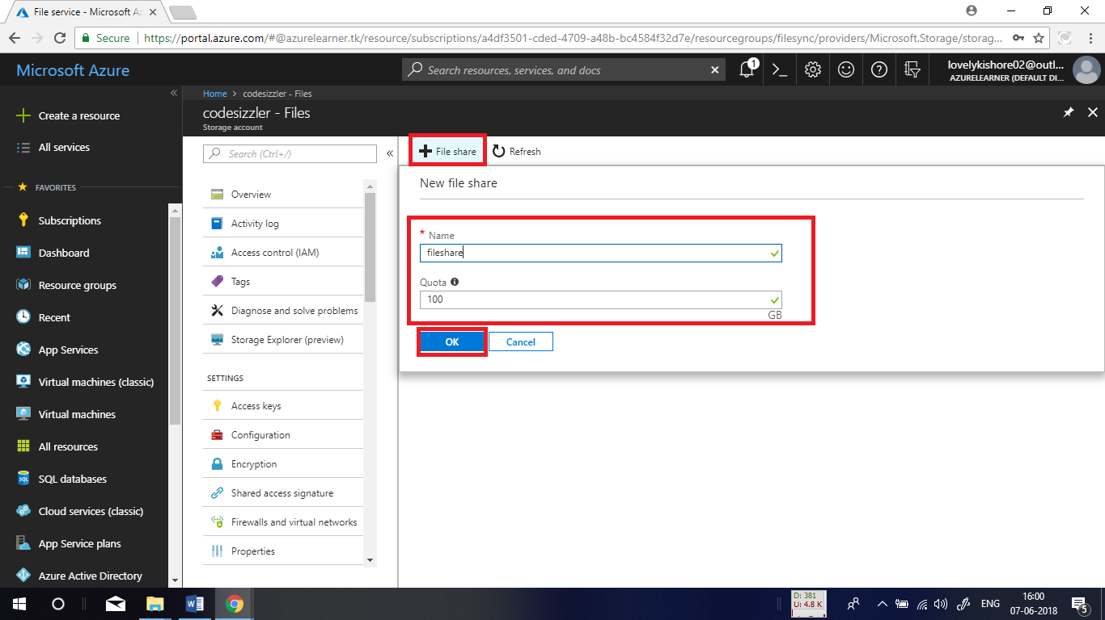

**Creating Azure File Sync:**

Go to **+ Create New resource** and choose **Storage->Azure File Sync.** Give an unique name, and choose the same location that is given in the image below. Choose a resource group and click on create.

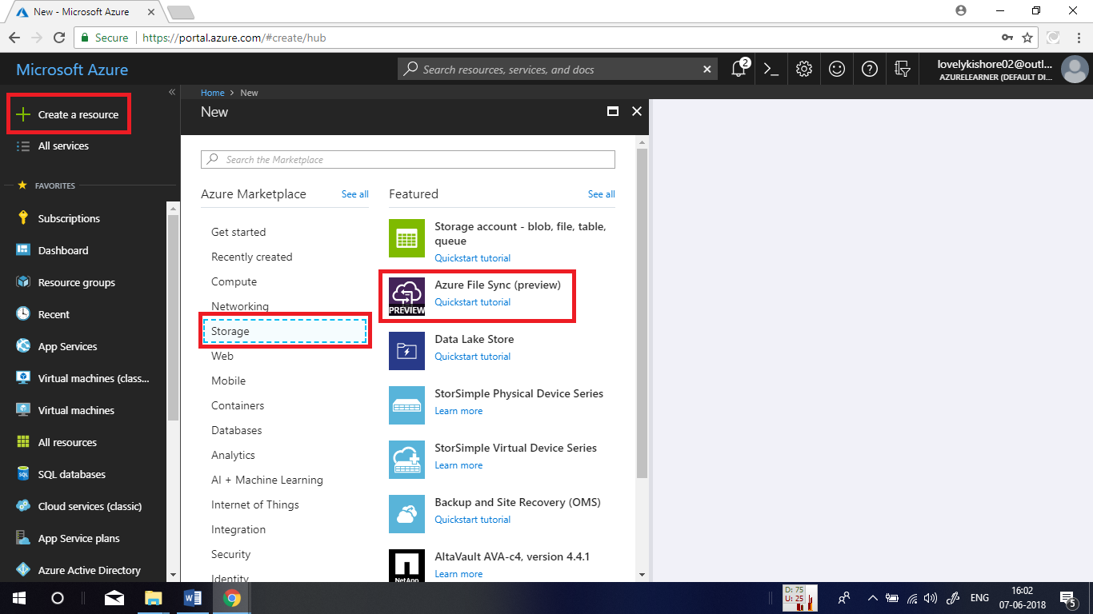

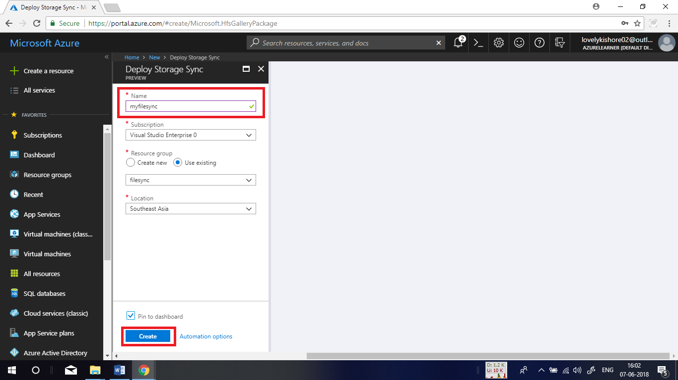

**Deploying Windows Server 2016 Virtual Machines:**

Go to **+ Create New resource** and choose **Compute->Windows Server 2016 Datacentre.** Give an unique name, and choose the same location that is given in the image below. Choose a resource group and click on create.

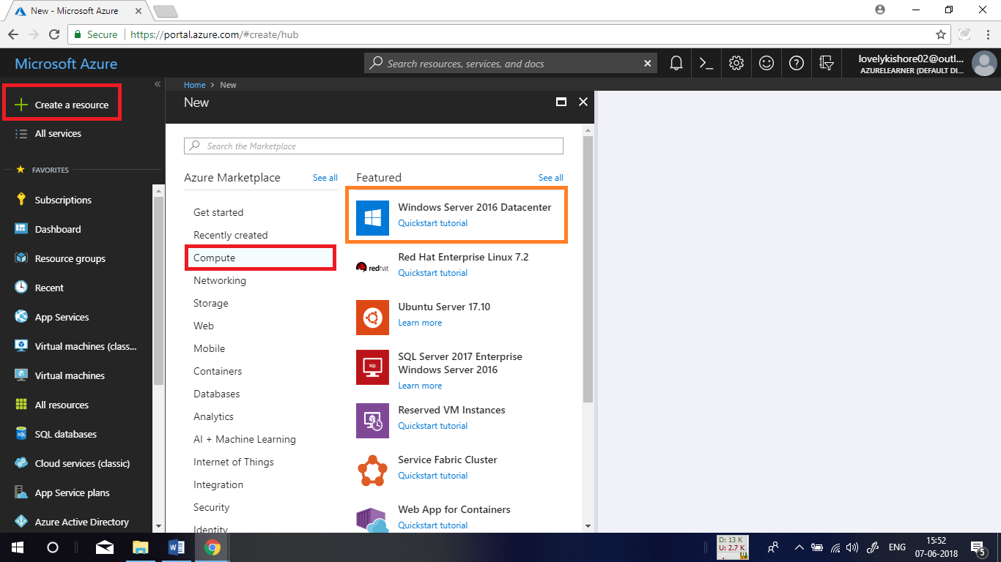

In the basic settings, give a name to VM, and choose the disk type that you like. Give an user name, a password for security purpose. Choose a resource group, location and click on **Ok.**

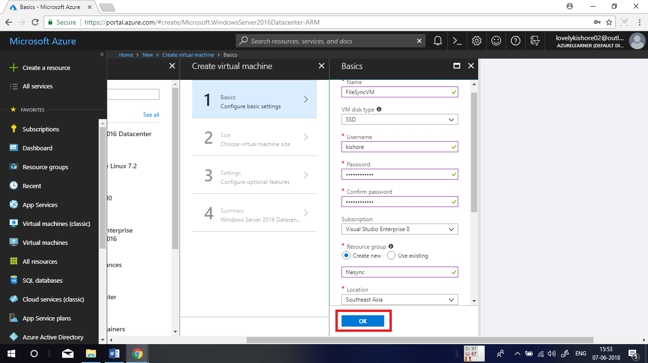

Choose a desired size base on your need.

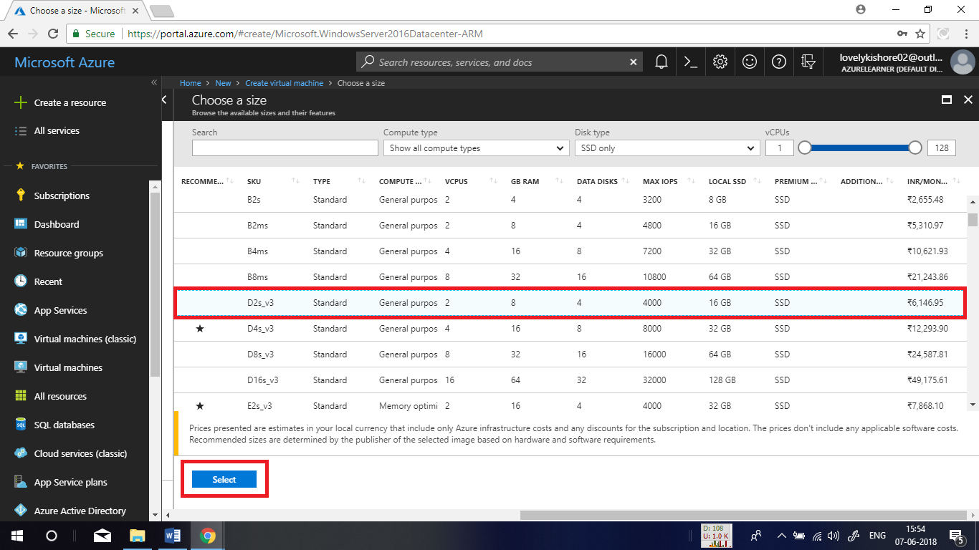

Leave the rest of settings as default and click on OK. Finally click on create.

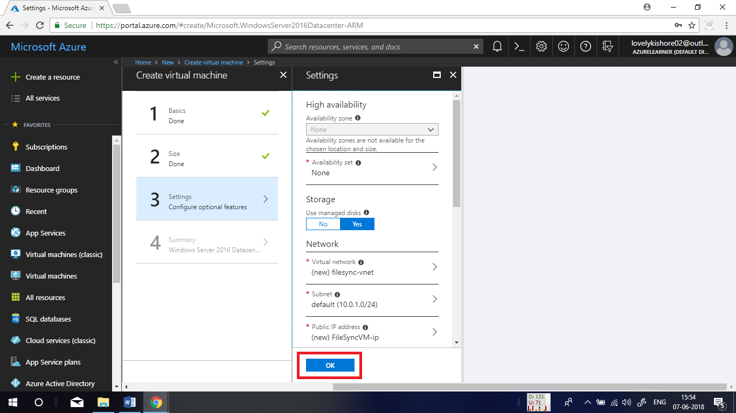

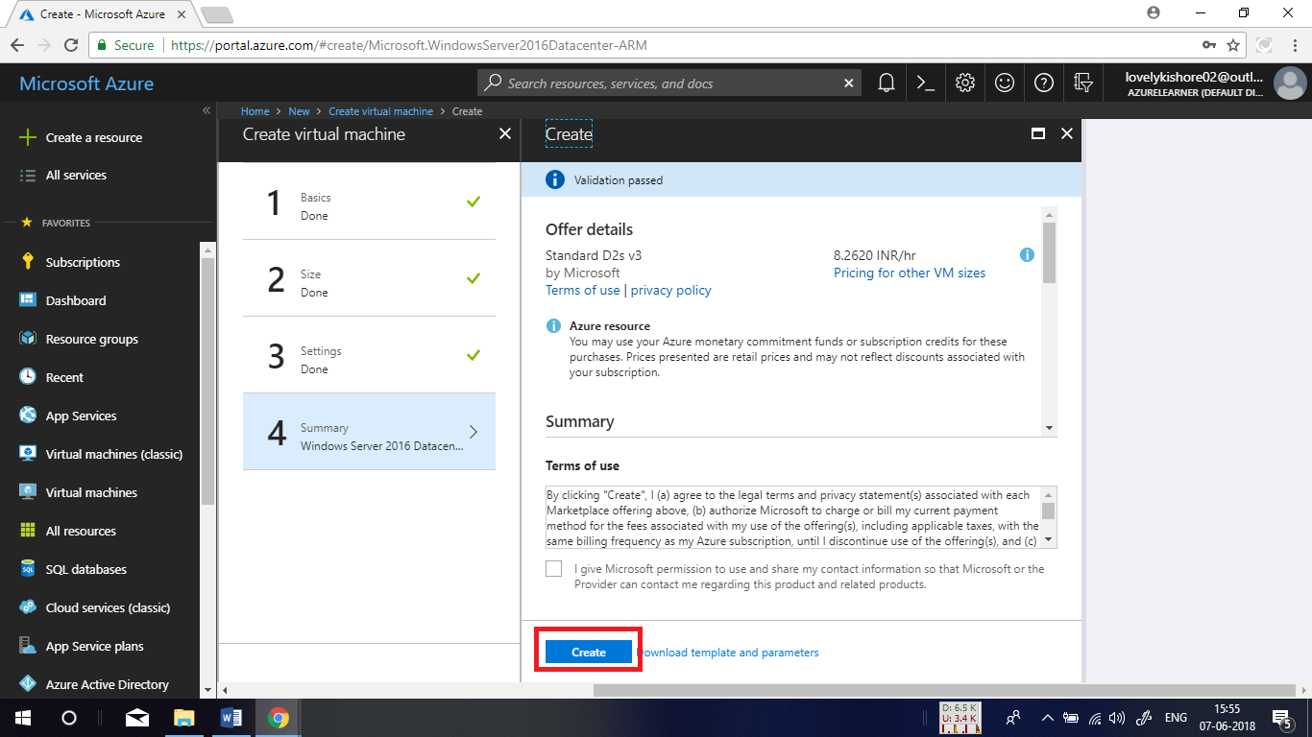

**Connecting to VM:**

In the overview page of the VM, click on connect option. Then download the TDP file and open it.

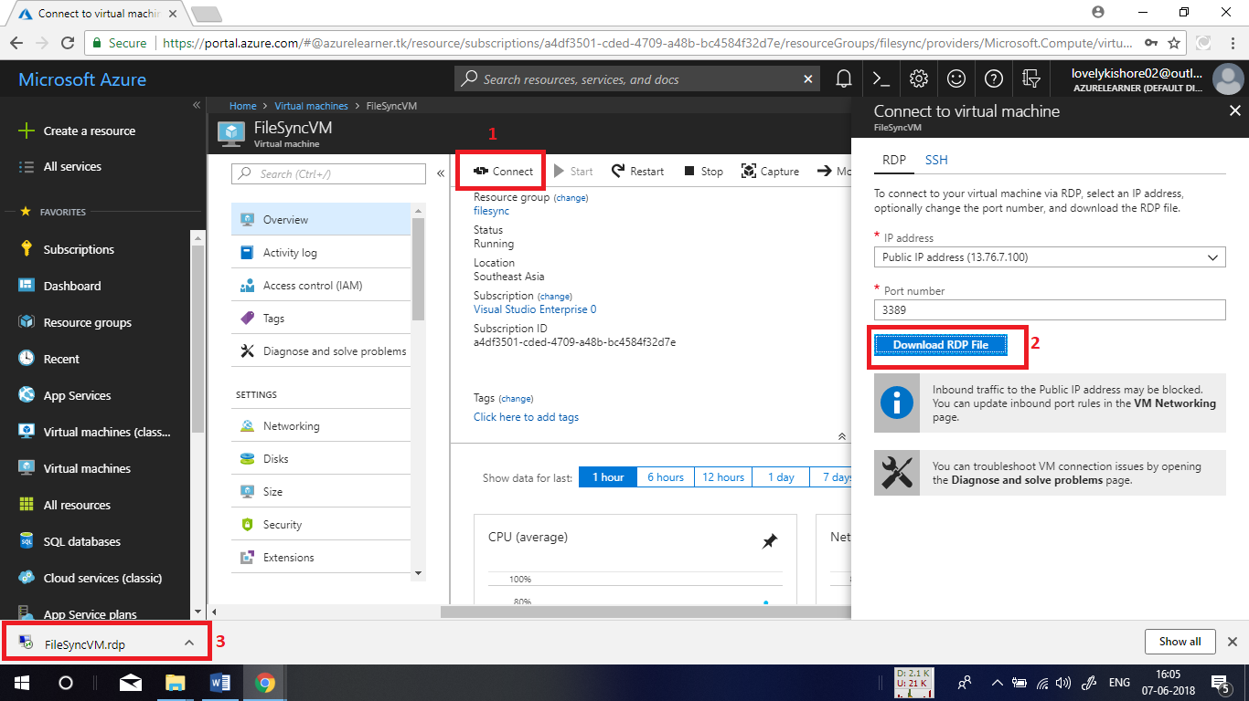

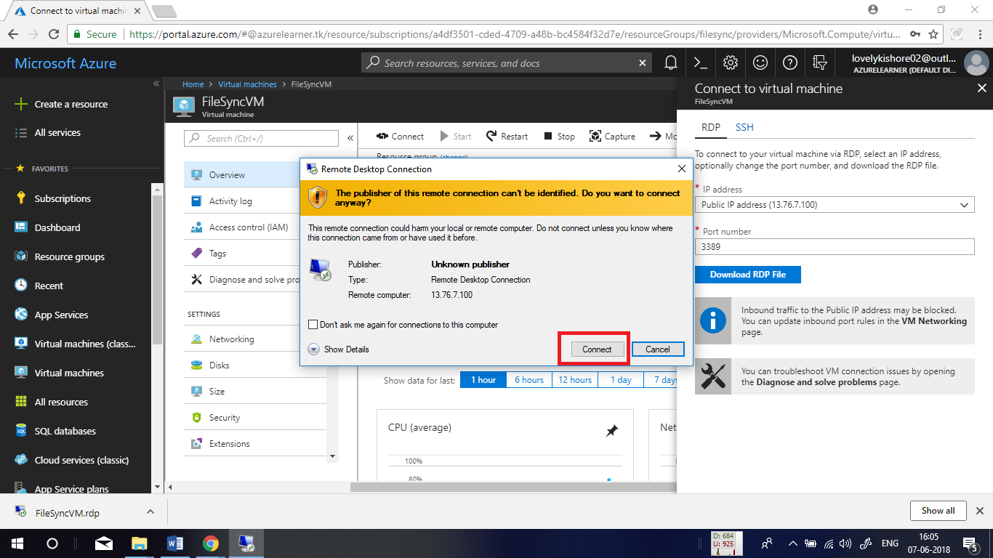

Now, enter the user name and password that you gave while configuring the VM and click on OK to authenticate into VM.

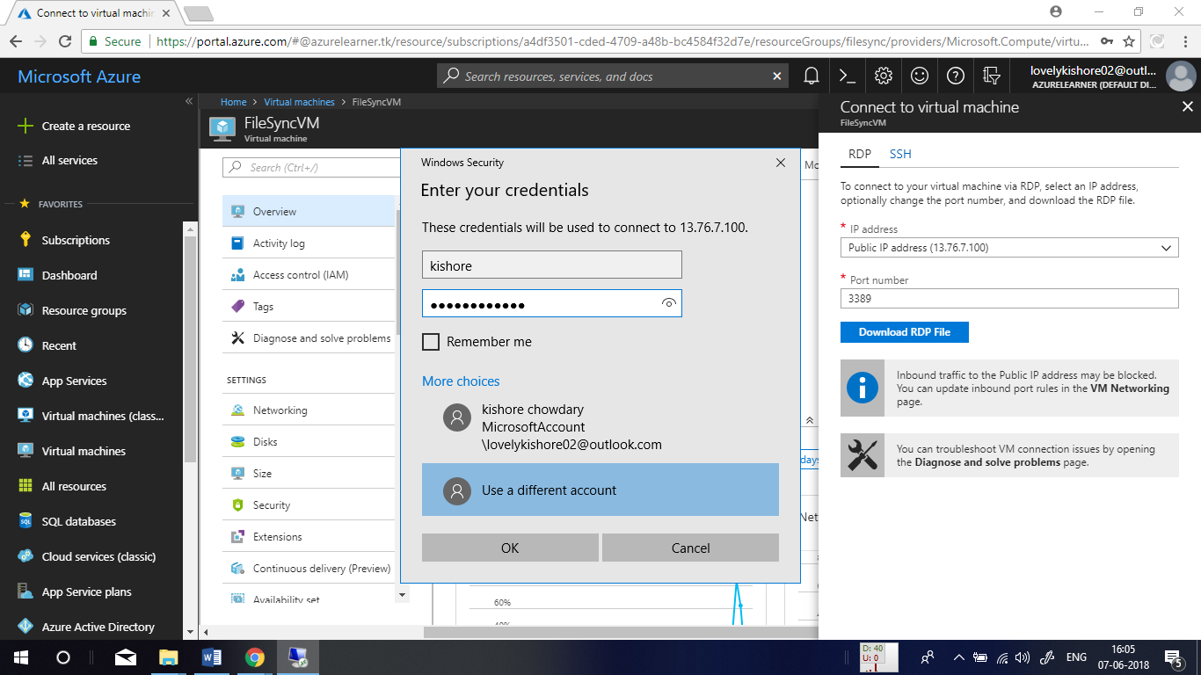

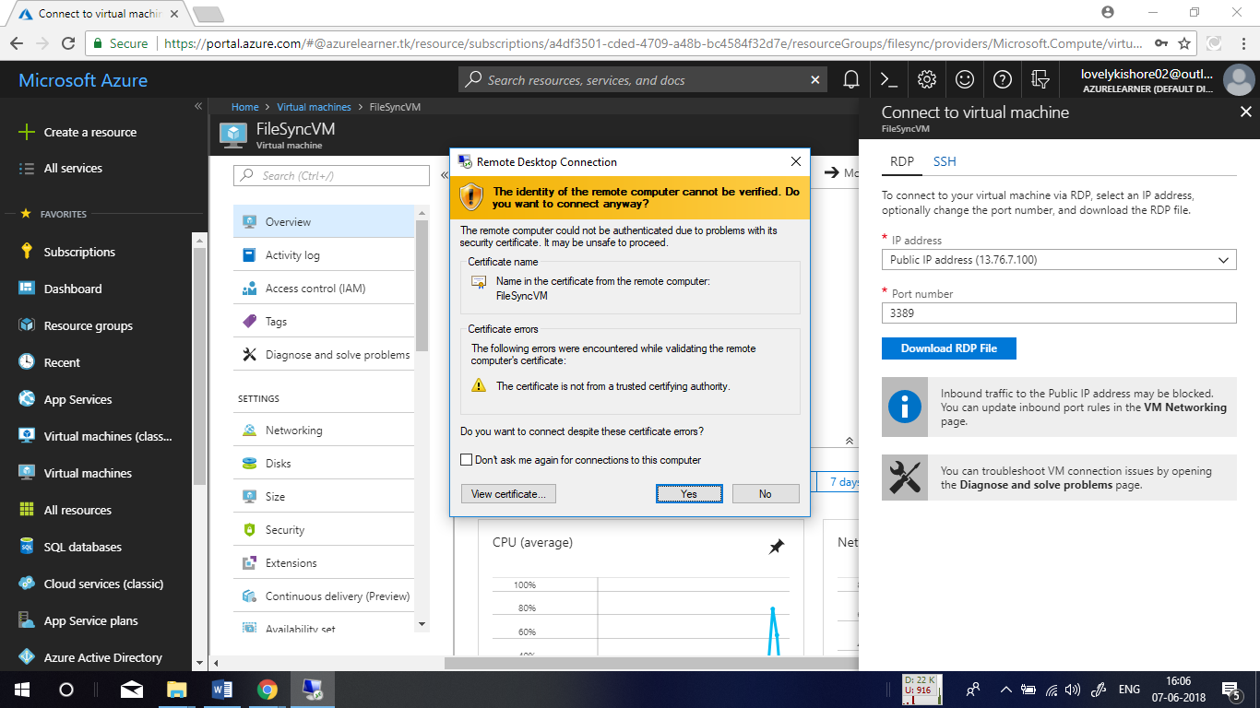

Once after you login into the VM, **Server Manager** will get opened by default. In there click on **Local Server** option in the left side menu and click on **IE Enhanced Security**. This will popup a window to turn of security. Turn of the security in here for both Administrator and User and click on Ok. This will remove the proxy in VM.

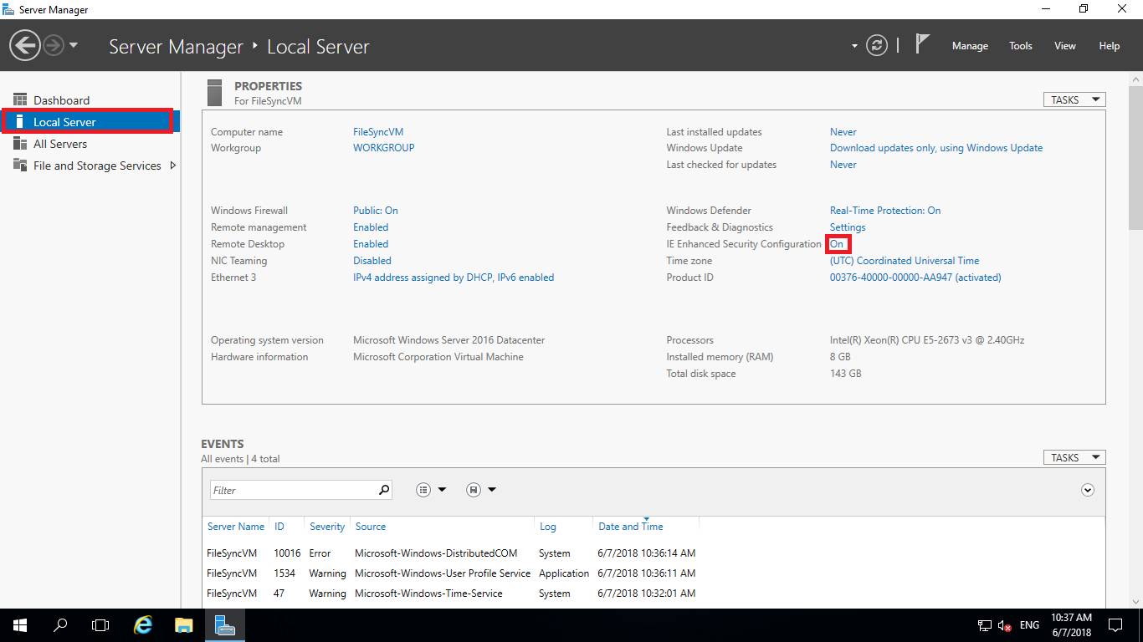

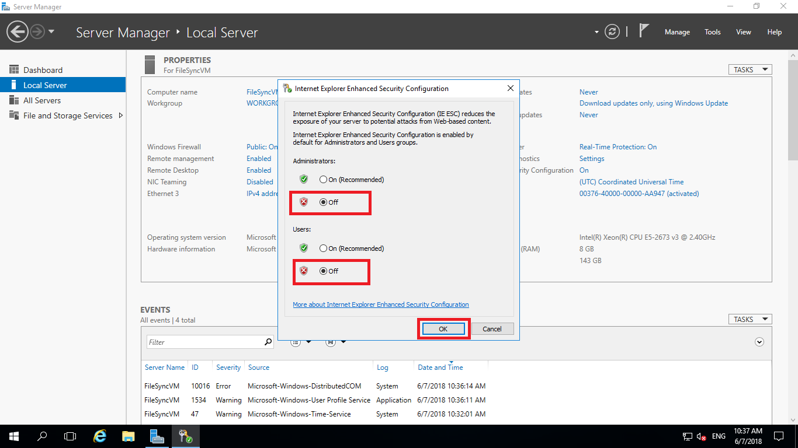

**Updating PowerShell:**

To work with Azure file sync, we need to update the PowerShell modules to the latest version. Windows Server operating system does not have packages installed in prior. Open the PowerShell by going to start menu. Run the below given set of commands one by one.

This command will install Azure PowerShell from PowerShell gallery.

**Get-Module -Name PowerShellGet -ListAvailable | Select-Object -Property Name,Version,Path**

This command is for updating the PowerShellGet.

**Install-Module PowerShellGet -Force**

This will install the Azure Resource Manager modules from the PowerShell Gallery.

**Install-Module -Name AzureRM -AllowClobber**

This is for loading the module into PowerShell.

**Import-Module -Name AzureRM**

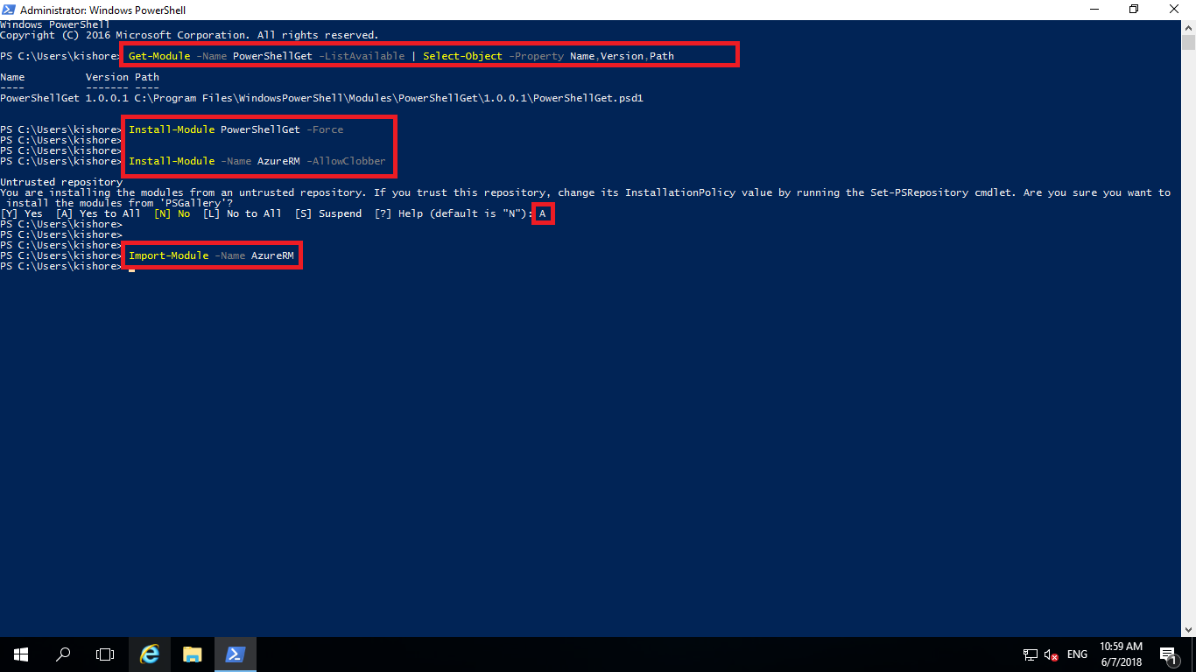

**Installing Azure File Sync Agent:**

Go to the following URL from the server machine to download the file.

<https://go.microsoft.com/fwlink/?linkid=858257>

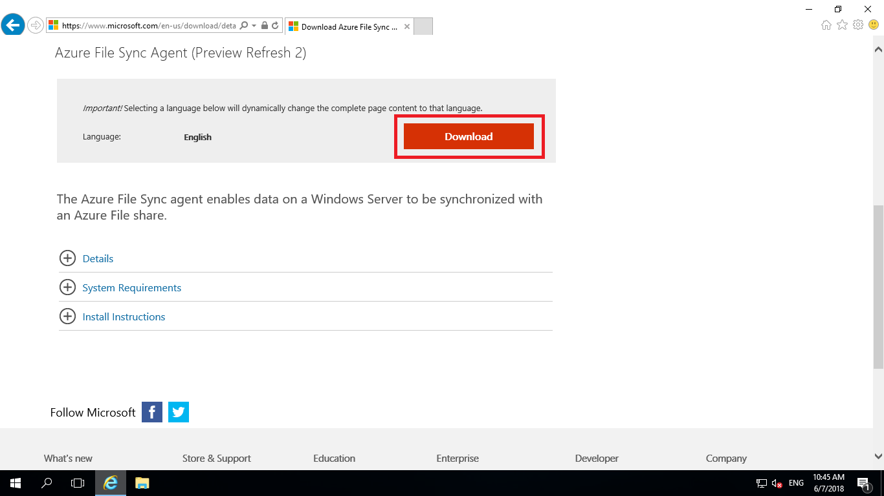

Select package according to the windows server version that you use and click on next.

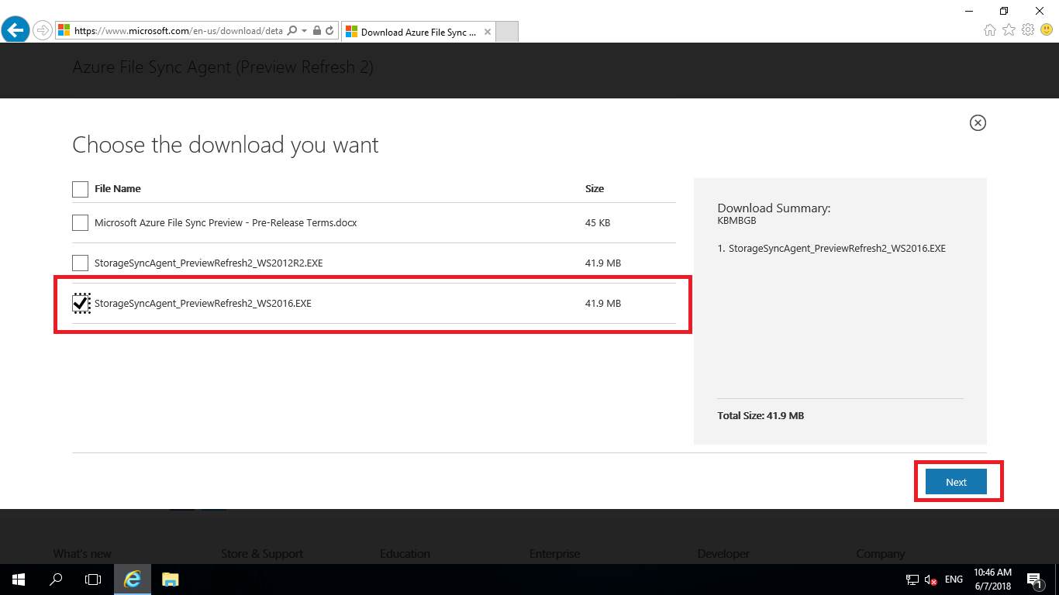

Once the download completes, open the file and install it as it is without changing any settings.

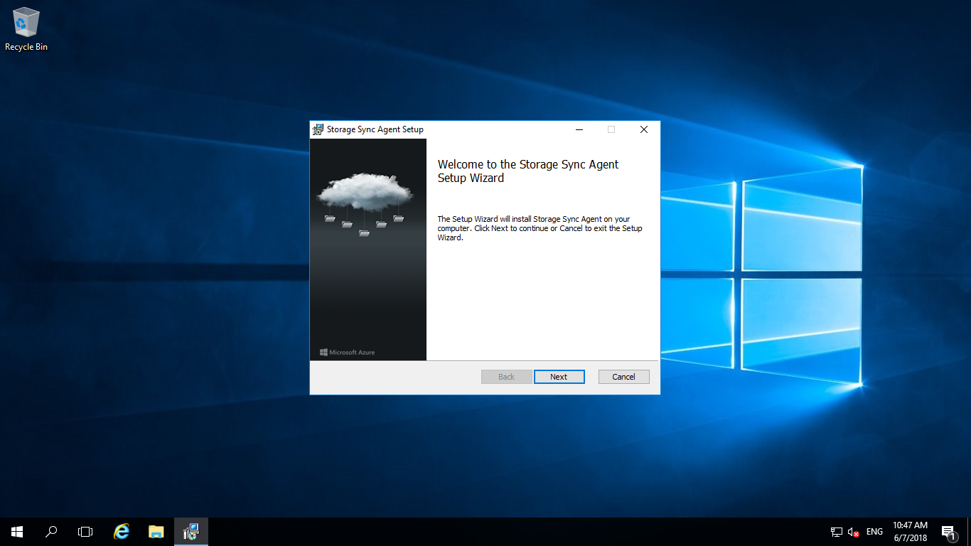

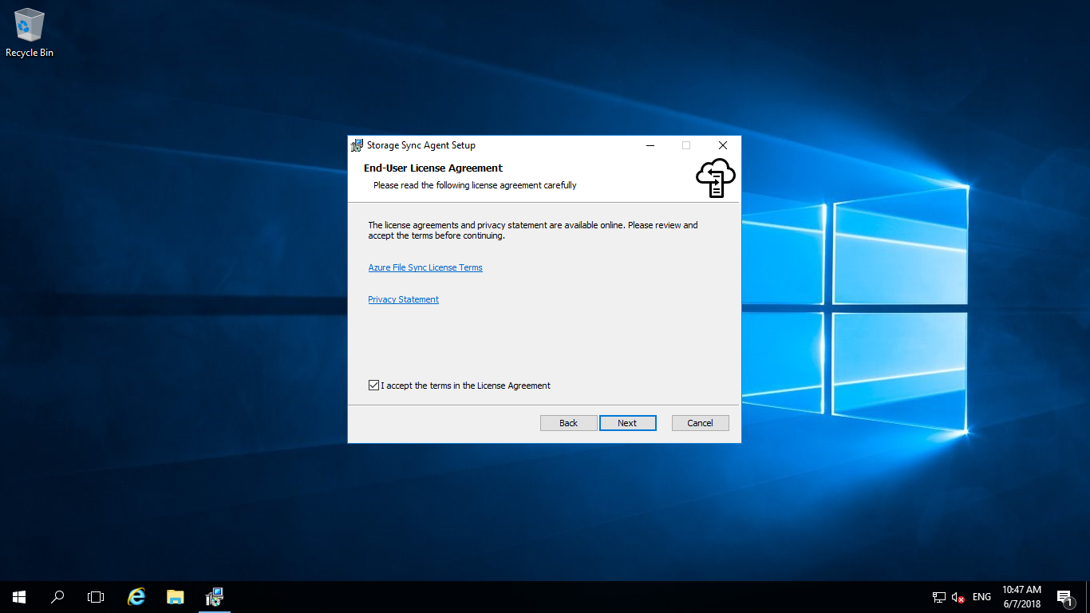

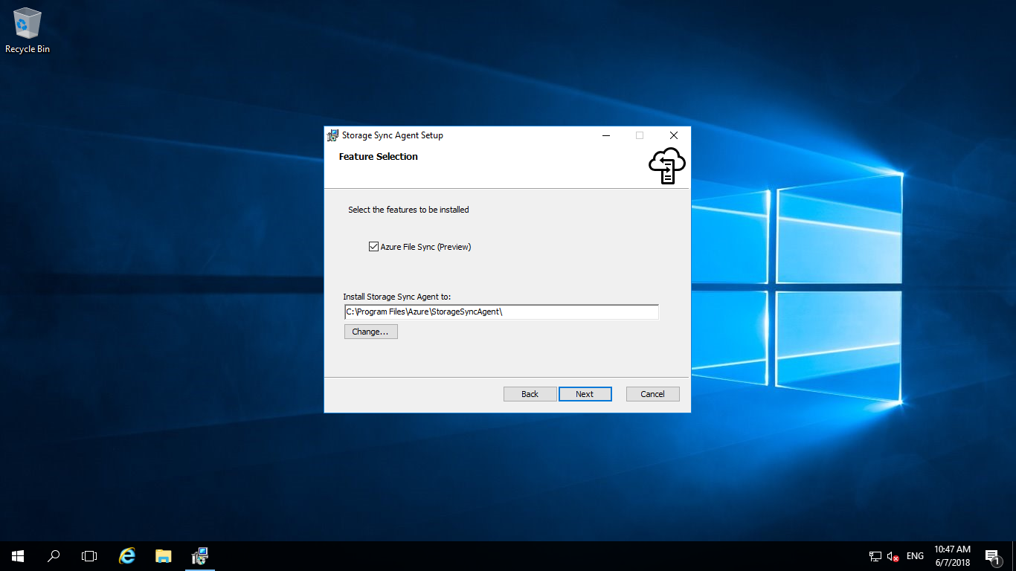

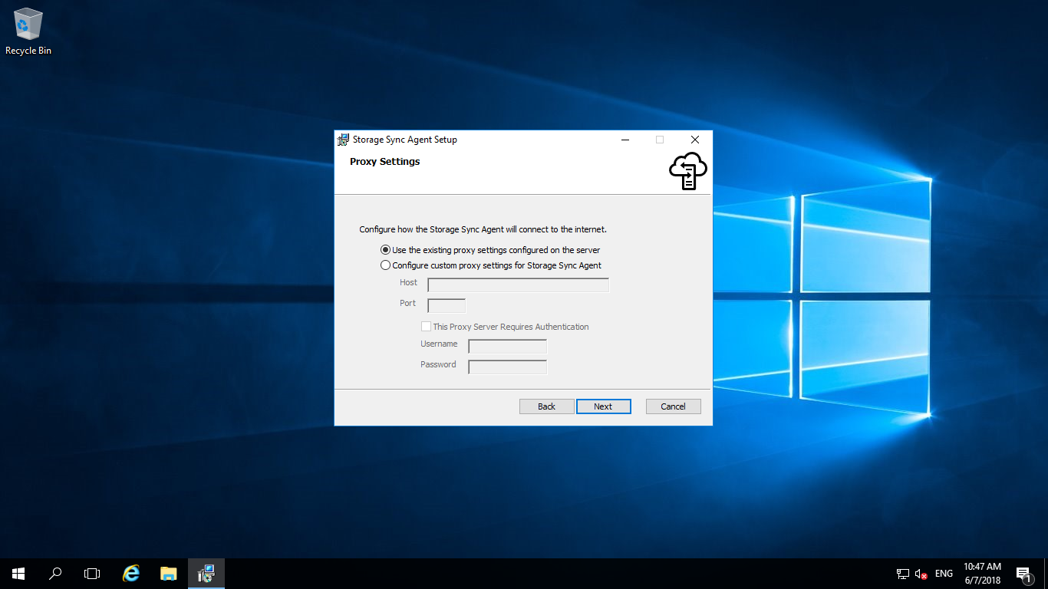

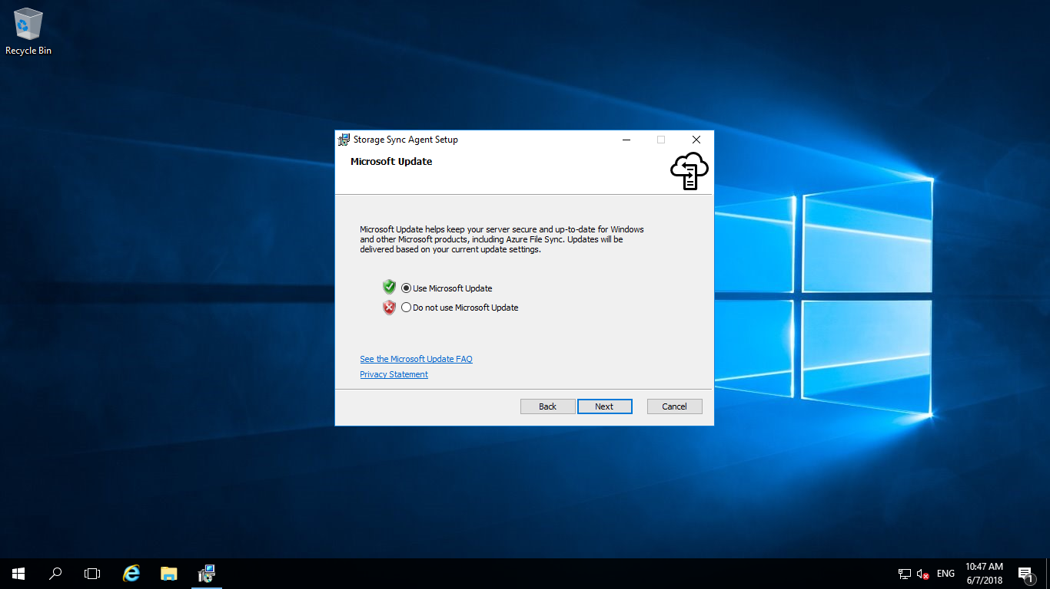

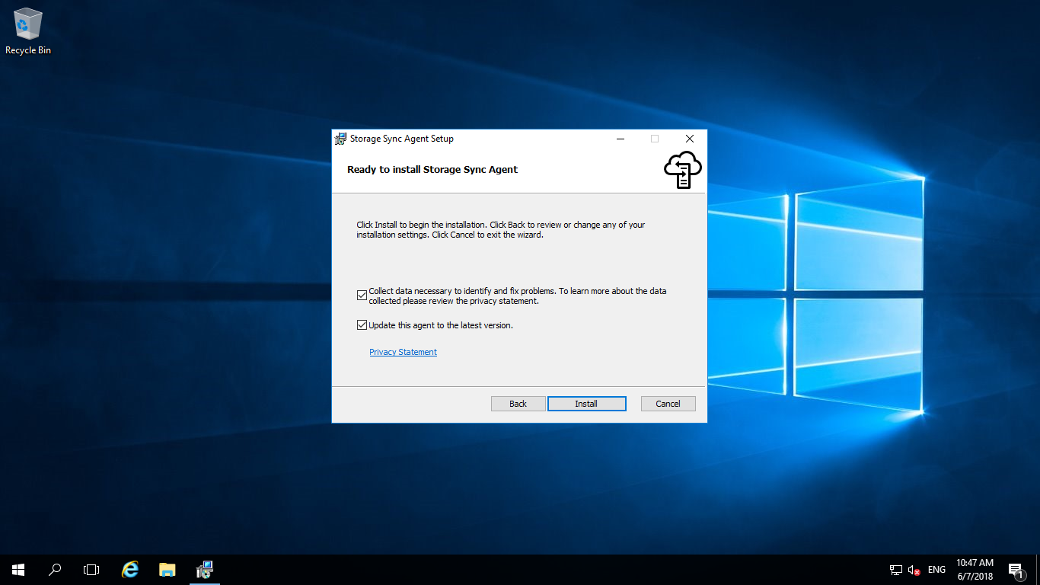

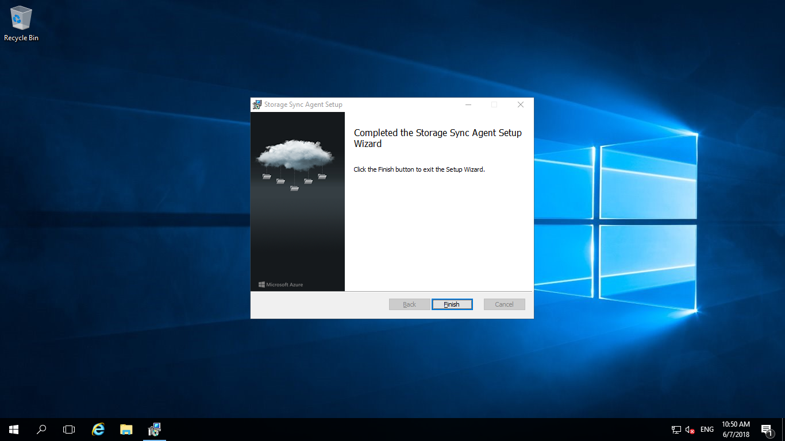

**Azure File Sync - Server Registration:**

Once after the agent gets installed, it will open by default. If you miss it, find the application in the path “C:\Program Files\Azure\StorageSyncAgent\ServerRegistration.exe”. In there click on **Sign In** to connect with your azure account where you have your file sync created.

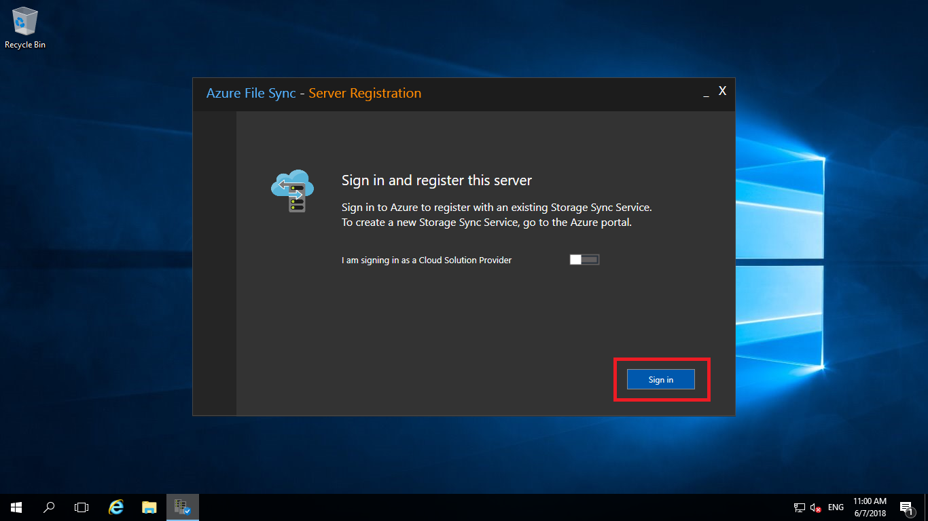

After logging in, select your subscription, resource group and file sync that you have created in the beginning and click on **Register**. You will be asked to authenticate once again by entering the user name and password. At last click on Ok to close the configuration.

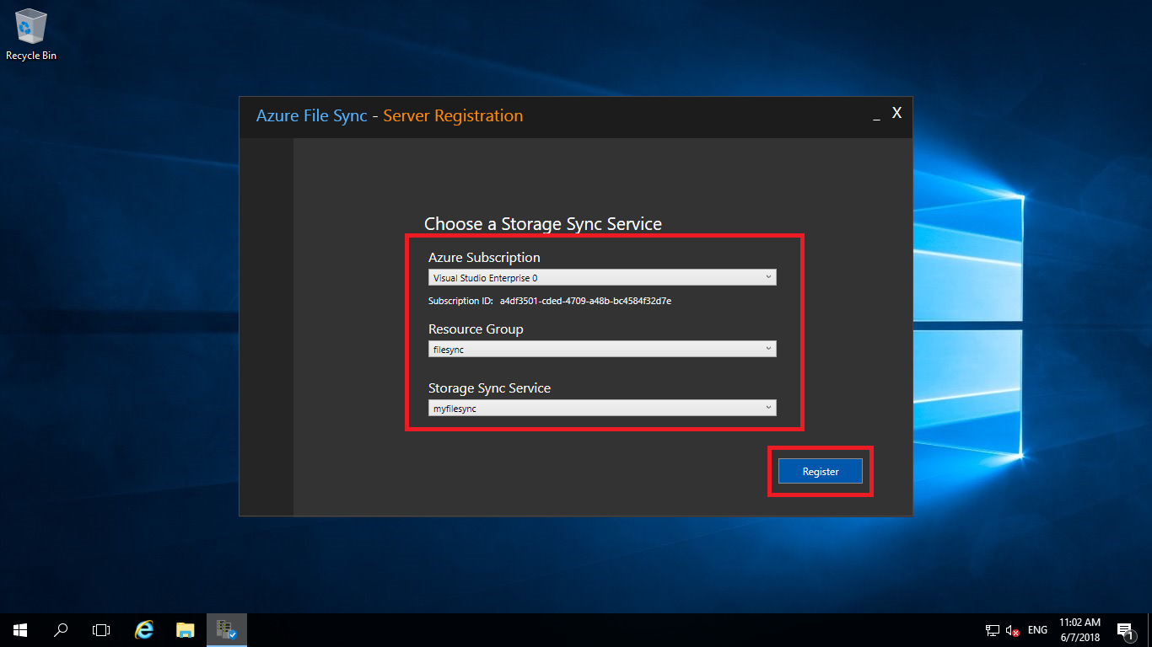

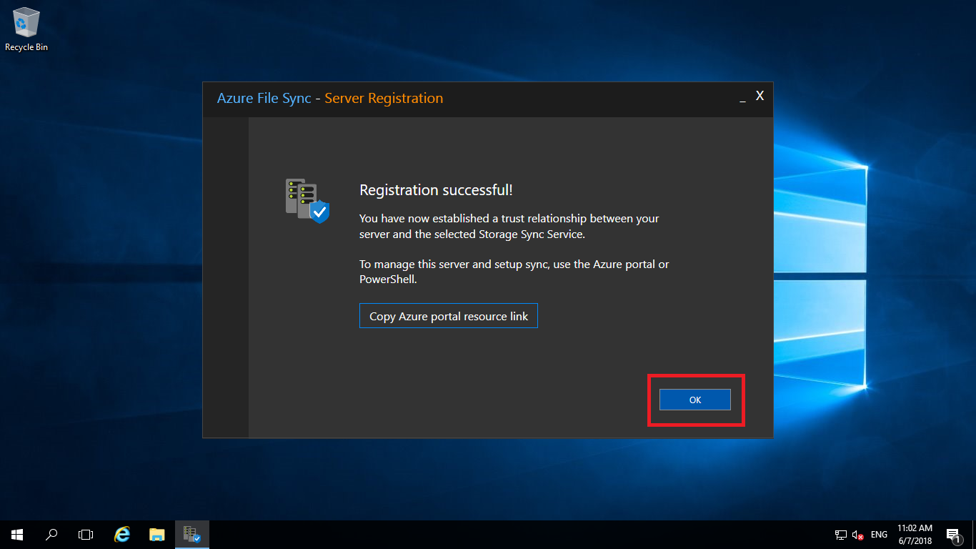

**Creating Sync Group:**

Now, come back to azure portal and open the file sync that you created in the beginning. In there click on **+ Sync Group** to add a group for synchronization. Give a name, choose the storage account and file share and click on create.

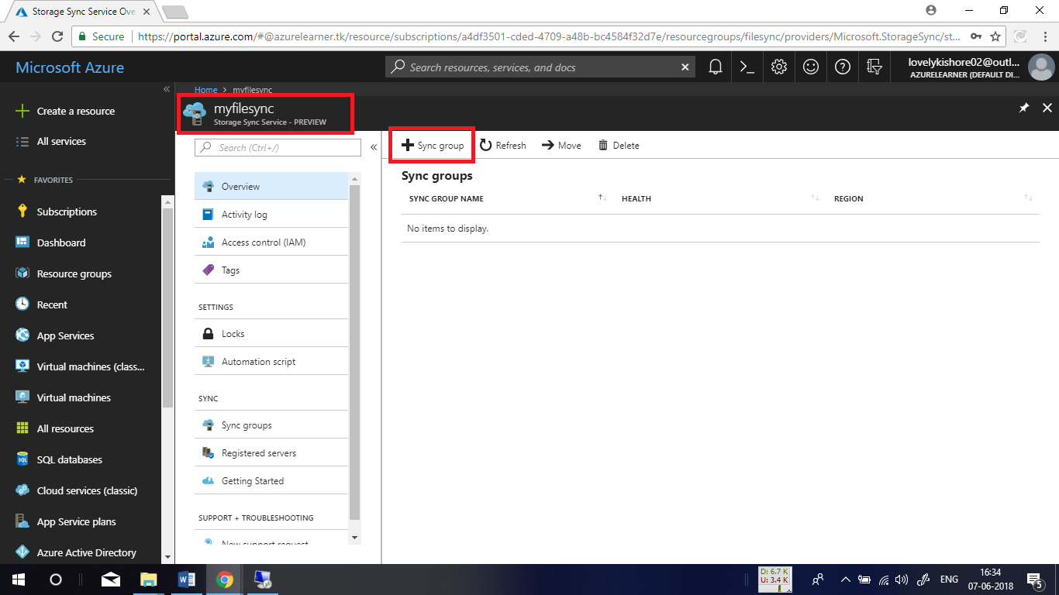

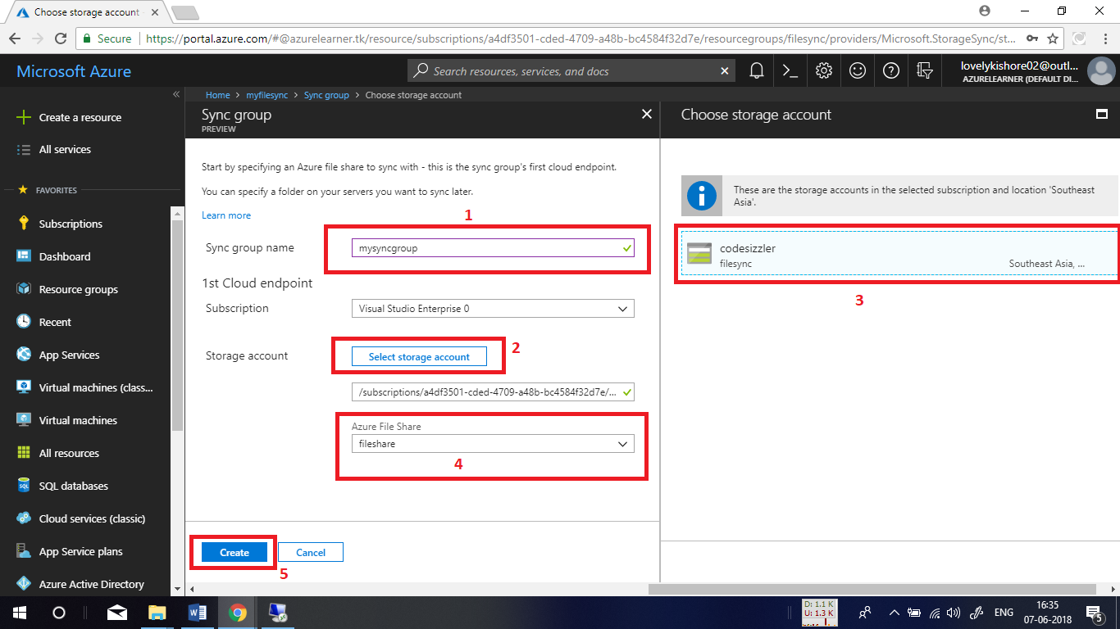

Now open the group that you created and click on **Add Server Endpoint** to connect the server machine for synchronizing files. Choose the server machine in there and in path give path of the files that you like synchronize. In this demo, we are trying to sync **local disk C**. At last click on **Create.**

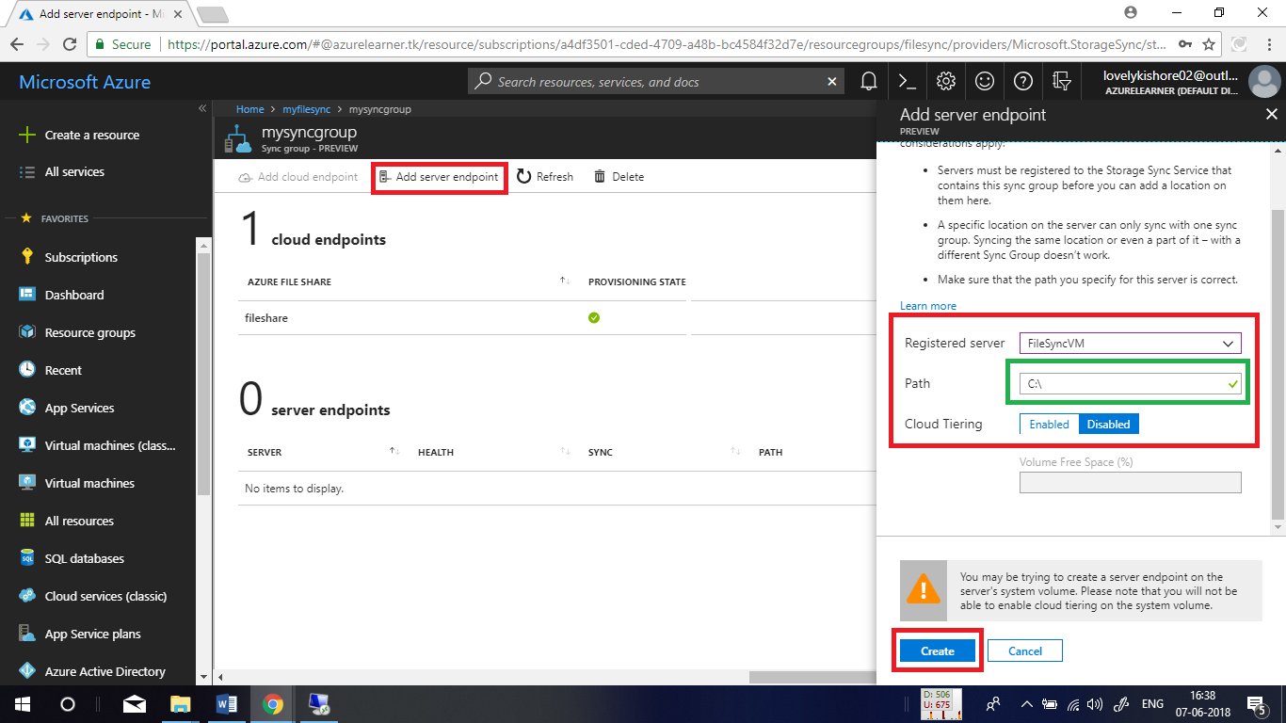

Once the create button is clicked, files will start synchronizing. To find the synchronized files, open the file share that you created in your storage account. You can find the files.

